
Fluid Flow Simulation Project Report

SOLIDWORKS Flow Simulation

Project Report

April 23, 2025

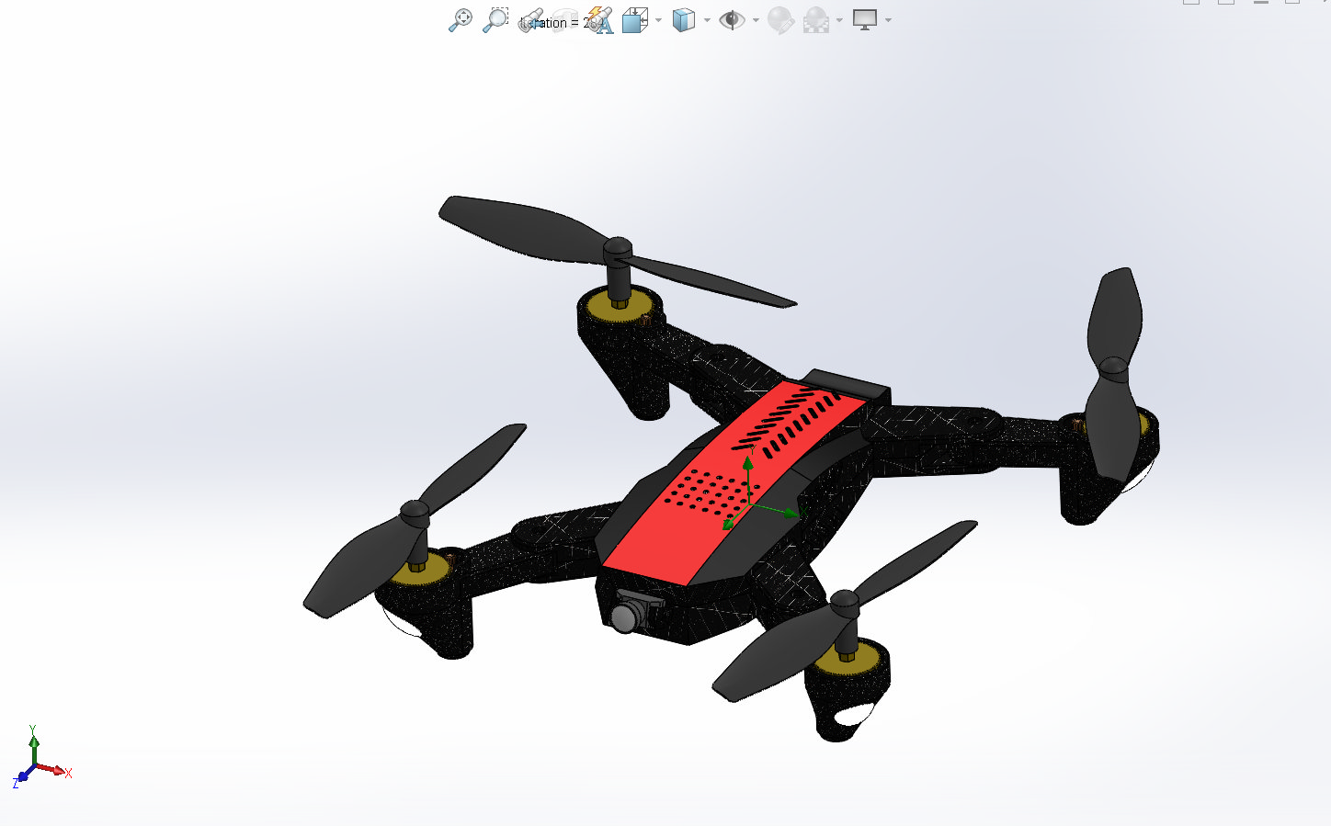

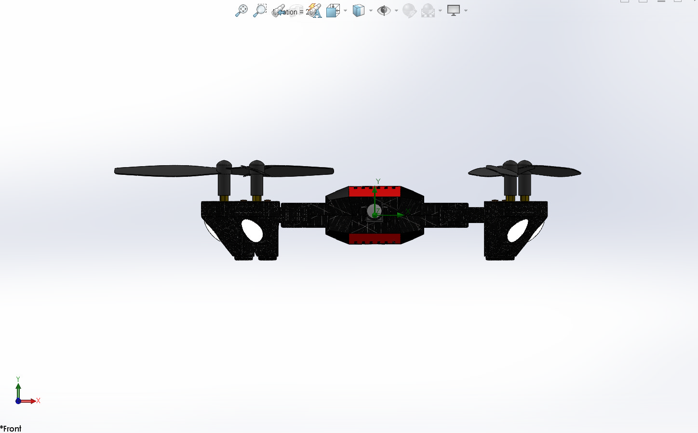

ANALYSED BY :AISHWARYA V SHAJU
Table of Contents

1 General Information 1
1.1 Analysis Environment 1
1.2 Model Information 1
1.3 Project Comments: 1
1.4 Size of Computational Domain 1
1.5 Simulation Parameters 1
1.5.1 Mesh Settings 1
1.5.2 Material Settings 2
1.5.3 Initial Conditions 2
1.5.4 Boundary Conditions 2
1.5.5 Volumetric Heat Sources 2
1.5.6 Engineering Goals 2
1.6 Analysis Time 2
2 Results 2
2.1 Analysis Goals 2
2.2 Global Min-Max-Table 2
2.3 Results 2
2.4 Conclusion 2
3 Appendix 2
3.1 Material Data 2

General Information

Objective of the simulation: The objective of this simulation is to perform Computational Fluid Dynamics (CFD) analysis on the Quadcopter drone using SolidWorks Flow Simulation to study its aerodynamic performance. The analysis aims to evaluate key parameters such as pressure distribution, airflow patterns, velocity profiles, and drag forces acting on the drone during flight. This will help in understanding the aerodynamic efficiency of the design and identifying potential areas for performance optimization or design improvement.

Analysis Environment
Software Product: Flow Simulation 2023 SP0.0. Build: 5726
CPU Type: 12th Gen Intel(R) Core(TM) i7-12650H
CPU Speed: 2300 MHz
RAM: 16015 MB / 3009 MB
Operating System: Windows 11 (or higher) (Version 10.0.22631)

Model Information
Model Name: drone final.SLDASM
Project Name: QUADCOPTER CFD

Project Comments:
Unit System: SI (m-kg-s)
Analysis Type: External (not exclude internal spaces)

Size of Computational Domain

Size
X min | -1.026 m
X max | 1.026 m
Y min | -0.351 m
Y max | 0.674 m
Z min | -1.018 m
Z max | 1.030 m
X size | 2.053 m
Y size | 1.024 m
Z size | 2.049 m

Simulation Parameters

Mesh Settings

Basic Mesh

Basic Mesh Dimensions
Number of cells in X | 54
Number of cells in Y | 37
Number of cells in Z | 56

Analysis Mesh
Total Cell count: 146497
Fluid Cells: 146497
Solid Cells: 3738
Partial Cells: 4607
Trimmed Cells: 0

Additional Physical Calculation Options
Heat Transfer Analysis: Fluid Flow: OnConduction: Off
Flow Type: Laminar and turbulent
Time-Dependent Analysis: Off
Gravity: Off
Radiation:
Humidity: Off
Default Wall Roughness: 0 micrometer

Material Settings

Material Settings
Fluids
Air

Initial Conditions

Ambient Conditions
Thermodynamic parameters | Static Pressure: 101325.00 Pa  Temperature: 293.20 K
Velocity parameters | Velocity vector  Velocity in X direction: 0 m/s  Velocity in Y direction: 0 m/s  Velocity in Z direction: 0 m/s
Turbulence parameters | Turbulence intensity and length  Intensity: 0.10 %  Length: 7.273e-04 m

Boundary Conditions

Volumetric Heat Sources

Engineering Goals

Goals
Global Goals
GG Average Temperature (Fluid) 1
Type | Global Goal
Goal type | Temperature (Fluid)
Calculate | Average value
Coordinate system | Global Coordinate System
Use in convergence | On

GG Average Total Temperature 2
Type | Global Goal
Goal type | Total Temperature
Calculate | Average value
Coordinate system | Global Coordinate System
Use in convergence | On

GG Minimum Velocity 3
Type | Global Goal
Goal type | Velocity
Calculate | Minimum value
Coordinate system | Global Coordinate System
Use in convergence | On

GG Maximum Velocity 4
Type | Global Goal
Goal type | Velocity
Calculate | Maximum value
Coordinate system | Global Coordinate System
Use in convergence | On

GG Minimum Velocity (X) 5
Type | Global Goal
Goal type | Velocity (X)
Calculate | Minimum value
Coordinate system | Global Coordinate System
Use in convergence | On

GG Maximum Velocity (X) 6
Type | Global Goal
Goal type | Velocity (X)
Calculate | Maximum value
Coordinate system | Global Coordinate System
Use in convergence | On

GG Minimum Velocity (Y) 7
Type | Global Goal
Goal type | Velocity (Y)
Calculate | Minimum value
Coordinate system | Global Coordinate System
Use in convergence | On

GG Maximum Velocity (Y) 8
Type | Global Goal
Goal type | Velocity (Y)
Calculate | Maximum value
Coordinate system | Global Coordinate System
Use in convergence | On

GG Minimum Velocity (Z) 9
Type | Global Goal
Goal type | Velocity (Z)
Calculate | Minimum value
Coordinate system | Global Coordinate System
Use in convergence | On

GG Maximum Velocity (Z) 10
Type | Global Goal
Goal type | Velocity (Z)
Calculate | Maximum value
Coordinate system | Global Coordinate System
Use in convergence | On

GG Force (Y) 11
Type | Global Goal
Goal type | Force (Y)
Coordinate system | Global Coordinate System
Use in convergence | On

GG Friction Force (Z) 12
Type | Global Goal
Goal type | Friction Force (Z)
Coordinate system | Global Coordinate System
Use in convergence | On

Analysis Time
Calculation Time: 307 s
Number of Iterations: 284
Warnings:

Results

Analysis Goals

Goals
Name | Unit | Value | Progress | Criteria | Delta | Use in convergence
GG Average Temperature (Fluid) 1 | K | 293.20 | 100 | 0.0013442501 | 0.00125569813 | On
GG Average Total Temperature 2 | K | 293.20 | 100 | 0.00132905654 | 0.0012801852 | On
GG Minimum Velocity 3 | m/s | 0 | 100 | 0 | 0 | On
GG Maximum Velocity 4 | m/s | 37.716 | 100 | 3.20027115 | 0.107670324 | On
GG Minimum Velocity (X) 5 | m/s | -37.695 | 100 | 2.7402889 | 0 | On
GG Maximum Velocity (X) 6 | m/s | 37.698 | 100 | 3.16391861 | 0 | On
GG Minimum Velocity (Y) 7 | m/s | -4.402 | 100 | 3.30185199 | 0.803596925 | On
GG Maximum Velocity (Y) 8 | m/s | 14.355 | 100 | 2.32110637 | 0.302453359 | On
GG Minimum Velocity (Z) 9 | m/s | -37.651 | 100 | 2.88364274 | 0 | On
GG Maximum Velocity (Z) 10 | m/s | 37.652 | 100 | 2.17221087 | 0 | On
GG Force (Y) 11 | N | -1.017 | 100 | 1.92235861 | 0.0582225385 | On
GG Friction Force (Z) 12 | N | 7.656e-05 | 100 | 0.000471996965 | 0.000107948732 | On

Global Min-Max-Table

Min/Max Table
Name | Minimum | Maximum
Density (Fluid) [kg/m^3] | 1.19 | 1.21
Pressure [Pa] | 100151.56 | 101669.36
Temperature [K] | 292.57 | 293.79
Temperature (Fluid) [K] | 292.57 | 293.79
Velocity [m/s] | 0 | 37.716
Velocity (X) [m/s] | -37.695 | 37.698
Velocity (Y) [m/s] | -4.402 | 14.355
Velocity (Z) [m/s] | -37.651 | 37.652
Mach Number [ ] | 0 | 0.11
Mach Number RRF [ ] | 0 | 0.12
Velocity RRF [m/s] | 0 | 42.236
Velocity RRF (X) [m/s] | -40.551 | 39.929
Velocity RRF (Y) [m/s] | -4.402 | 14.355
Velocity RRF (Z) [m/s] | -41.091 | 39.990
Vorticity [1/s] | 0 | 5705.53
Relative Pressure [Pa] | -1173.59 | 344.22
Shear Stress [Pa] | 0 | 5.51
Bottleneck Number [ ] | 0 | 1.0000000
Heat Transfer Coefficient [W/m^2/K] | 0 | 0
ShortCut Number [ ] | 0 | 1.0000000
Surface Heat Flux [W/m^2] | 0 | 0
Surface Heat Flux (Convective) [W/m^2] | 0 | 0
Total Enthalpy Flux [W/m^2] | -2936550.328 | 1959019.093
Acoustic Power [W/m^3] | 0 | 2.768e-07
Acoustic Power Level [dB] | 0 | 54.42

Results
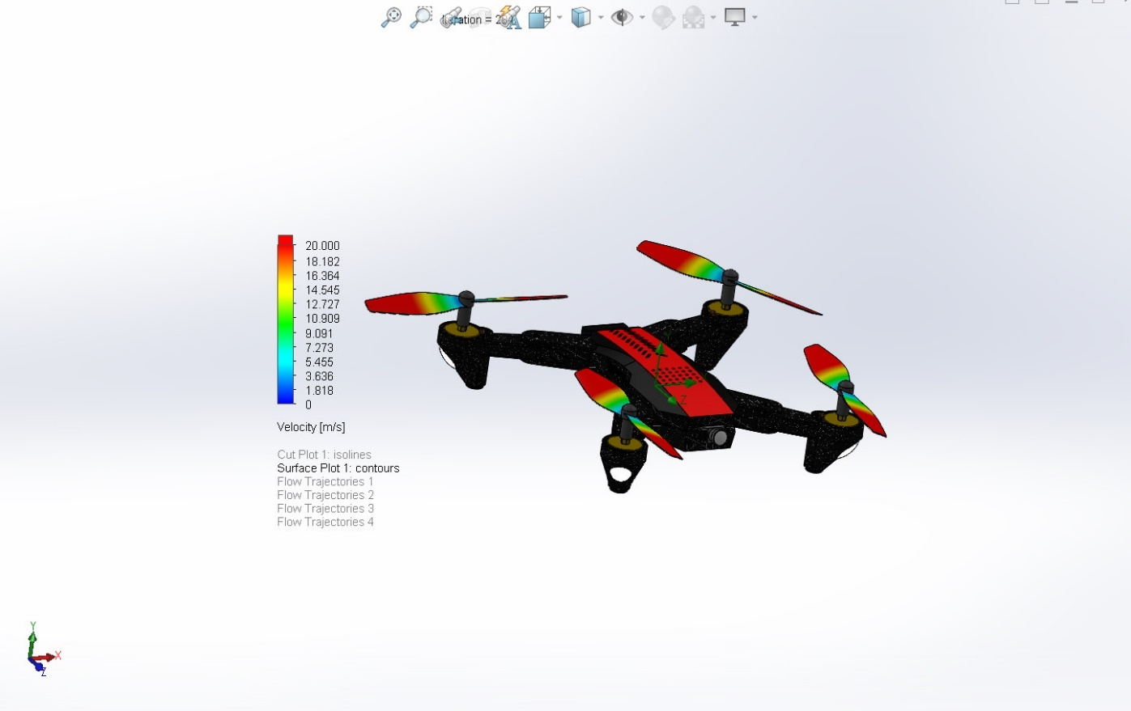

SURFACE PLOT
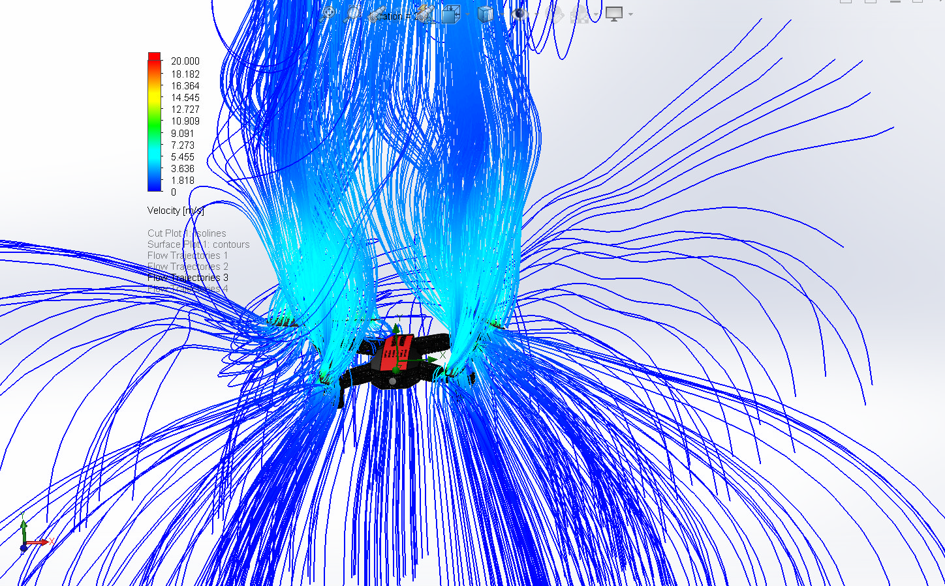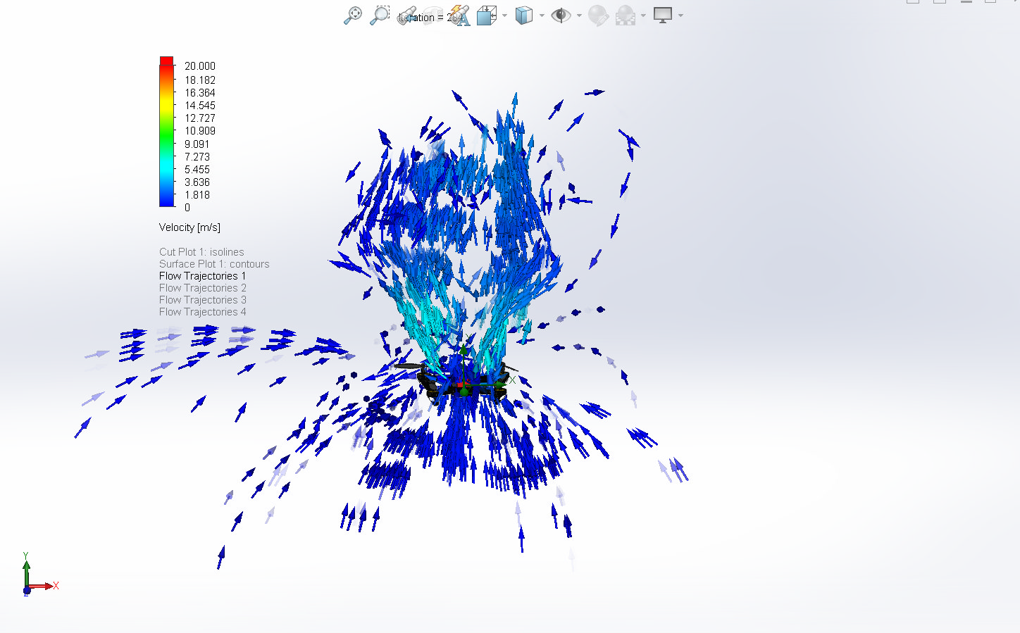

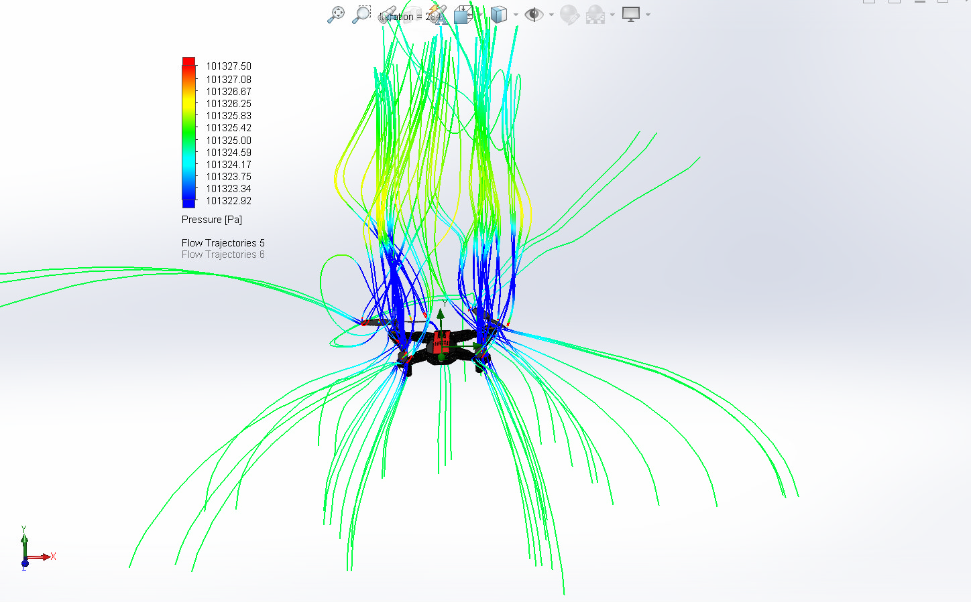

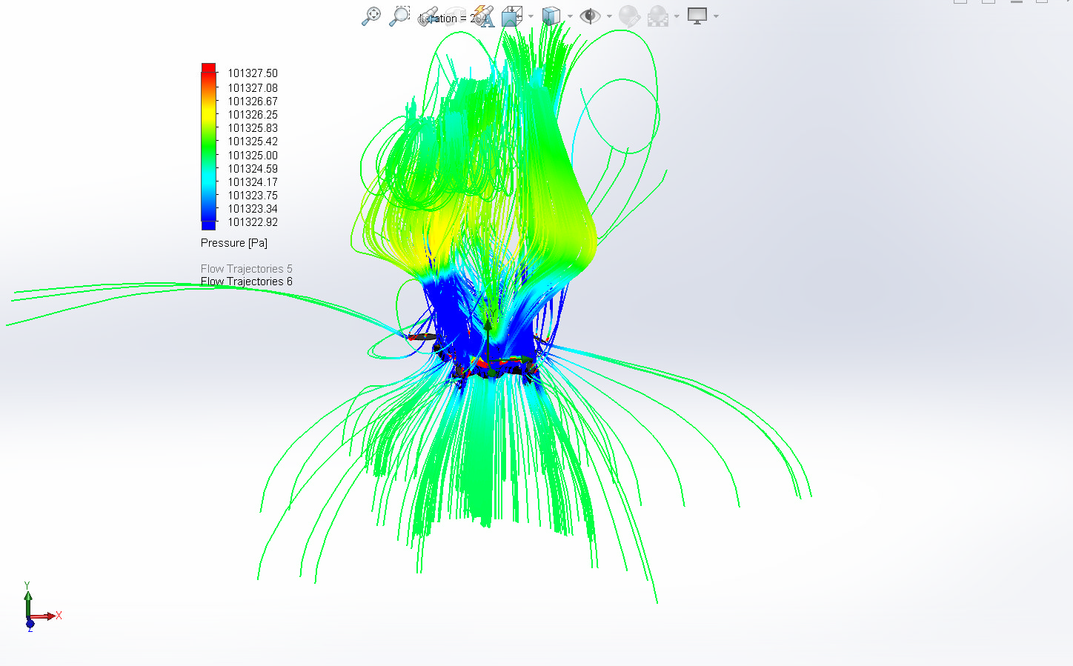

FLOW TRAJECTORIES

Conclusion

The CFD simulation conducted on the Predator MQ-9 drone successfully provided insights into its aerodynamic performance under defined flight conditions. The analysis revealed the airflow behavior around the fuselage and wings, highlighted regions of high and low pressure, and quantified drag forces acting on the drone.
From the results, it can be inferred that the aerodynamic design of the drone is optimized for steady flight with minimal turbulence and controlled pressure distribution. However, certain areas—such as wing-fuselage junctions or tail surfaces—may benefit from further refinement to reduce drag or improve lift-to-drag ratio.
Overall, this simulation demonstrates the importance of CFD analysis in validating and optimizing UAV designs for enhanced performance, stability, and efficiency during flight.

Appendix

Material Data

Engineering Database
Gases
Air
Path: Gases Pre-Defined
Specific heat ratio (Cp/Cv): 1.399
Molecular mass: 0.0290 kg/mol
Dynamic viscosity

Specific heat (Cp)

Thermal conductivity

